MAKERERE UNIVERSITY
College of Computing and Information Sciences
School of Computing and Informatics Technology, Department of Networks
BSE4104: Emerging Trends in Software Engineering
Week 1 Capstone Report
Public Procurement Document Completeness Agent
Project Charter, Use Case Definition, System Architecture and AI Boundary Matrix
Prepared by Group H (Evening)
No. | Name | Registration Number
1 | Makmot Johnson Kabira | 23/U/26794/EVE
2 | Mwesigwa Isaac | 23/U/12539/PS
3 | Bataringaya Bridget | 23/U/07471/EVE
4 | Jonathan Katongole | 23/U/27072/EVE
Course and Institution: BSE4104, Makerere University (CoCIS)
Focus Use Case: Ugandan Public Procurement, PPDA Compliance and Preliminary Verification
Status: Draft prepared for BSE4104 capstone submission, Week 1

Contents
1. Introduction 5
2. Problem Statement and Domain Context 5
2.1 Regulatory Background 5
2.2 Current Process 6
2.3 Problem Statement 6
3. Project Charter Summary 7
3.1 Purpose and the Value AI Adds 7
3.2 Scope 7
3.3 Assumptions 7
3.4 Constraints 8
4. Primary User Profile 8
4.1 Who the User Is 8
4.2 Current Pain Points 9
4.3 What the User Actually Wants 9
5. Use Case Definition 9
5.1 Actors 10
5.2 Inputs and Outputs 10
5.3 Preconditions and Postconditions 10
5.4 Main Flow 11
5.5 Alternative and Exception Flows 11
5.6 System Boundary 11
6. End to End Workflow 12
7. System Architecture 13
7.1 System Context 13
7.2 Component Architecture 13
7.3 Data Flow 15
7.4 Design Rationale 15
7.5 Candidate Technologies 15
7.6 Assumptions and Constraints Carried Into This Architecture 16
8. AI Boundary and Safety Matrix 16
9. Traceability 18
10. Information Gap Register 18
11. Team and Roles 19
12. Conclusion 19
References 20

List of Tables
Table 1. End to end workflow stages, from tender upload to sign off 12
Table 2. Component descriptions 14
Table 3. Candidate technologies by architectural layer, not yet confirmed 15
Table 4. AI boundary and safety matrix 16
Table 5. Traceability from problem to proposed functionality 18
Table 6. Information gap register 18

List of Figures
Figure 1. System context: actors, the proposed system, and its external dependencies 13
Figure 2. Proposed component architecture, prior to any technology selection 14

1. Introduction
This report brings together the work carried out in Week 1 of the capstone project for Group H (Evening): the project charter, the definition of the selected use case, a first proposal for the system architecture, and the boundary matrix that keeps the agent's authority in check. The four pieces were originally written as separate working documents. They are combined here into a single account so that a reader can follow the project from the problem it responds to, through to the shape of the system being proposed, without having to move between files.
The project is a public procurement document completeness agent, referred to throughout this report as the Agent or as ProcureCheck. Given a tender submission and a published procurement checklist, the Agent locates each required item within the submission and reports whether it is present, missing, or uncertain enough to need a human look. It does not score a bid, rank bidders against each other, or recommend an award. Those decisions stay with the procurement officer, both because the team has chosen to keep them there and because, as the case law discussed in Section 2 shows, they are the kind of judgement Uganda's procurement tribunal reserves for a human evaluation committee in any case.
Everything that follows is written the way it was actually developed: some points are confirmed project decisions, some are proposals still open for discussion, and a few are genuine information gaps the team has not yet resolved. Where that distinction matters, it is kept visible rather than smoothed over, mainly in Section 10, which lists what is still unresolved.

2. Problem Statement and Domain Context

2.1 Regulatory Background
Public procurement in Uganda is governed by the Public Procurement and Disposal of Public Assets Act, 2003 (Cap. 205), which created the Public Procurement and Disposal of Public Assets Authority, generally referred to as the PPDA, as the body responsible for regulating procurement and asset disposal. The Act has been amended more than once since then, most notably in 2011 and again in 2021 (Public Procurement and Disposal of Public Assets Authority, 2003, as amended 2011 and 2021).
Bid evaluation itself is set out in more detail in the Public Procurement and Disposal of Public Assets (Evaluation) Regulations, 2023, together with the Standard Bidding Documents the PPDA issues, which every Procuring and Disposing Entity is required to use unless it has been granted a specific, PPDA approved exception (Ministry of Education and Sports, 2021; Public Procurement and Disposal of Public Assets Authority, n.d.-a). One recognised stage within that process is what the Standard Bidding Documents call the preliminary examination of bids for eligibility and administrative compliance, in which the procuring entity checks a bidder's legal documentation and other submitted paperwork before moving on to the technical and financial evaluation (Ministry of Education and Sports, 2021).
This preliminary stage is the one the project targets. It is, by its own description in the Standard Bidding Documents, a matching exercise: comparing what a checklist or bidding document requires against what a bidder has actually submitted, rather than a judgement about the technical or commercial merit of the bid.

2.2 Current Process
Under the standard PPDA process, a bidder typically assembles a submission containing items such as a business registration certificate, a tax clearance certificate, financial statements, relevant technical certifications or licences, a record of past experience, bid security, and a set of required declarations, for example on non-blacklisting, conflict of interest, and anti-corruption compliance (Public Procurement and Disposal of Public Assets Authority, n.d.-a; Ithy, 2025). The evaluation committee at the procuring entity, which by rule must include a member of its Procurement and Disposal Unit, carries out this preliminary check manually against the bidding document's requirements before any technical or commercial evaluation begins (Public Procurement and Disposal of Public Assets Authority, n.d.-b; Ministry of Education and Sports, 2021).
For the academic scope of this project, that process is treated as generically manual: a human reviewer reading a submission against a checklist. No single procuring entity's internal workflow, staffing arrangement, or existing tooling has been confirmed as the project's specific reference case, and this remains a stated assumption rather than a verified fact.

2.3 Problem Statement
Missing or non conforming documentation is a documented cause of bid disqualification within Uganda's procurement system. In Chint Meters and Electrical Uganda Company Ltd v Uganda Electricity Distribution Company Ltd, the Procurement Appeals Tribunal upheld a disqualification for failing to supply required samples, and held that the clarification mechanism available under the PPDA Evaluation Regulations, 2023 is narrowly limited and cannot be used to cure a material omission in a bid (Lawpoint Uganda, 2025). In a more recent case, D and D Law Publishing House Limited, in joint venture with Mail Solutions UK Limited trading as Kalamazoo, v Uganda National Examinations Board, a joint venture bid was disqualified over a missing beneficial ownership disclosure, which the Tribunal treated as a defect in eligibility documentation rather than something a clarification request could fix (Procurement Appeals Tribunal, 2026).
Industry legal commentary goes further, describing missing documents as the most common cause of bid disqualification under the current rules (Global Advisory Experts, 2026). That claim is cited here as a secondary, non official source and should be read as a reported industry view rather than an official PPDA statistic.
The team's own project charter describes the same problem at the level of day to day work: tender submissions are long, containing many forms, declarations, clauses, attachments and supporting documents, and a required item can be overlooked simply because it sits under an unfamiliar heading, is buried inside an attachment, or is worded differently from the checklist itself. The charter identifies the core difficulty as the repetitive manual effort of establishing completeness, not the later evaluation of the bid's actual merit. Contributing factors named in the charter include the need to move constantly between checklist and submission across many attachments, inconsistent recording of findings between different reviewers, and the tendency for a missing item to surface late, causing rechecking and delay.
Taken together, these three sources line up: the PPDA's own process documents define a checklist style preliminary examination stage; real Tribunal decisions show that a missed item at that stage can end in outright disqualification with no route back through clarification; and the team's charter independently confirms the same failure pattern from the working reviewer's point of view. A tool that helps a reviewer, or a bidder preparing its own submission, reliably see which required items are present and which are not addresses a real and evidenced difficulty, without needing to touch the legal question of materiality that the Tribunal has made clear is reserved for the evaluation committee and, on appeal, for itself.

3. Project Charter Summary
The project charter sets out, at the level the team agreed on together, why the project exists, what it will and will not attempt, and the conditions it has to work within. This section summarises that charter.

3.1 Purpose and the Value AI Adds
The purpose of the project is to build a faster and more consistent first pass completeness check. The Agent examines a sample tender submission against a published checklist and reports whether the required documents, sections, or clauses can be found. Its role stops at administrative assistance. Final procurement decisions remain entirely with authorised human users.
The charter is specific about where the AI actually helps. Rather than relying only on exact keyword matching, the Agent can interpret a checklist requirement and search for text expressing the same requirement in different words, which matters because bidders rarely phrase things identically to the checklist. In practical terms, this means the Agent extracts the requirements contained in a checklist or template, searches a submission for the corresponding clause, form, or declaration, classifies each item as found, not found, or needing human review, records where the supporting evidence was located, and produces a structured completeness report that makes the missing and uncertain items easy for a human reviewer to check. The charter is equally clear that the AI assists with document understanding and retrieval; it does not replace procurement judgement, and any uncertain result goes to the user for confirmation rather than being treated as final.

3.2 Scope
In scope: published procurement templates and completeness checklists, synthetic or anonymised sample tender submissions, checking for the presence of required documents, sections and clauses, locating supporting evidence, identifying missing or uncertain items, and producing a traceable completeness report for human review.
Out of scope: bid scoring, ranking or comparison of bidders, deciding bidder eligibility, automatically disqualifying a bidder, drawing legal conclusions, recommending a contract award, approving a procurement, determining fraud or criminal liability, and any other rights affecting or enforcement action. The system may state that evidence was found, was not found, or requires human review, but that finding is never allowed to become an official procurement decision on its own.

3.3 Assumptions
- A published procurement checklist, tender template, or similar reference document exists and can be turned into a clear list of requirements.
- The sample tender submissions used for the prototype are machine readable, or can be converted to readable text with an acceptable loss of formatting.
- Synthetic or anonymised submissions can represent enough of the structure and wording of real procurement documents to support meaningful testing.
- The system can point the user to the exact location of a piece of evidence, so that a human can independently verify anything important.
- Human users remain responsible for every official procurement, legal, eligibility, and award decision.
- The team will have access to a suitable language model and document processing tools for extracting, searching, and matching text.
- The initial prototype can reasonably focus on a manageable set of document types and checklist requirements rather than every possible procurement procedure.

3.4 Constraints
- Data access. Real tender submissions can contain confidential or commercially sensitive information, so development and testing rely on public templates together with synthetic or properly anonymised submissions.
- Document quality. Scanned pages, embedded images, tables, poor formatting, and inconsistent file naming can all reduce how accurately text is extracted and matched.
- Language ambiguity. A submission can satisfy a requirement without using the checklist's exact wording, which is why some cases are flagged for human review rather than settled outright by the Agent.
- Model reliability. A language model can miss relevant evidence or match unrelated text by mistake, so every finding needs to stay traceable and easy for a human to check.
- Safety boundary. The system must never score or rank bids, decide eligibility, draw legal conclusions, recommend a contract award, or take any rights affecting procurement action.
- Time and resources. As an academic prototype, the project is reasonably limited to a selected set of templates, document formats, and checklist categories that can actually be built and tested within the time available.
- Human oversight. The system remains an assistant throughout. A human reviewer stays in control of the final interpretation of every completeness finding, and of anything done after the report is produced.

4. Primary User Profile
The primary user of the Agent is the officer responsible for the preliminary administrative examination of tender submissions within a Ugandan public procuring entity. This persona was worked out before the workflow that follows, because the workflow only makes sense once it is clear who will actually open the tool, what they already know how to do, and what currently gives them trouble.

4.1 Who the User Is
- Role: procurement officer or evaluation committee secretary within a procuring and disposing entity.
- Setting: public ministries, departments and agencies, municipalities, and public universities, for example the Procurement and Disposal Unit at Makerere University.
- Background: typically holds a degree in procurement and supply chain management, business administration, or law. Comfortable with everyday office software such as Word, PDF readers, and email, but has little to no background in artificial intelligence, so the interface needs to stay in plain, familiar language rather than technical terminology.
- Job to be done: check submitted tender proposals against the published PPDA preliminary examination checklist before evaluation can proceed.
A secondary user also matters to the design: a supplier or bid preparation team checking its own draft submission for missing documents before it is sent in. The same underlying workflow serves this user with no changes beyond who is doing the uploading.

4.2 Current Pain Points
- Tender submissions are long, often one hundred to several hundred pages per bidder, and a single tender can attract ten to thirty separate bidding packages, all of which have to be checked inside a fourteen day statutory window.
- Officers currently scroll through unstructured PDF files by hand, looking for specific statutory documents such as tax clearance certificates, trading licences, NSSF clearance, powers of attorney, litigation history, and bid securing declarations.
- Because the work is repetitive and carried out under time pressure, something is easy to miss. A missed omission can turn into an administrative review, a bidder appeal, or an audit finding later on.
- Bidders do not structure their submissions the same way, so there is no shortcut. Every document has to be read on its own terms rather than matched against one fixed template.

4.3 What the User Actually Wants
- To get through the preliminary check faster without skipping anything, ideally checking every mandatory item and not only the obvious ones.
- To be able to justify every decision afterward. If a bidder is flagged for a missing document, the officer needs to point to the exact page, not just state an opinion.
- To keep the actual decision making power. The tool should surface evidence and gaps; it should never be the one deciding whether a bidder passes or fails.
In the officer's own words, roughly rendered: “I need something that can read through hundreds of pages of a tender quickly and tell me exactly which mandatory documents or clauses are present or missing, and show me the page, so I can verify it myself and sign off without worrying about it coming back as a legal appeal.”

5. Use Case Definition
The selected use case is the public procurement document completeness agent described throughout this report. Given a sample tender submission and a published checklist, or a checklist derived from a Standard Bidding Document, the Agent locates each required item within the submission and produces a missing item report for a human reviewer. Its scope is limited to document parsing and checklist matching. It identifies presence or absence; it does not evaluate technical merit, price, or eligibility, and it produces no recommendation about the bid's outcome.

5.1 Actors
- Primary actor: a procurement administrative officer or document reviewer who needs to confirm that a tender package contains everything a published checklist requires, before deeper evaluation begins.
- Secondary actor: a supplier or bid preparation team checking its own draft package for missing documents before submission.
- A third role is implicit in the acceptance criteria: a system auditor who confirms that the Agent actually respects its safety boundary, meaning no scoring, no ranking, no legal conclusions, and no award recommendations.
An external checklist source, a published procurement checklist or template uploadable as a PDF, CSV, or plain text file, also plays a role, though no integration with the PPDA's electronic government procurement portal or any other live system has been confirmed. This remains an open item rather than an assumption made either way, and is tracked in Section 10.

5.2 Inputs and Outputs
The system takes two inputs: a published procurement checklist or template, uploaded as a PDF, CSV, or text file and parsed into a list of required items the user can edit before running a check; and a sample tender submission, synthetic or anonymised in line with the charter's data handling constraint, uploaded in a machine readable or OCR convertible format. Which specific checklist instance and procurement sector will be used for prototype development has not yet been chosen and is listed as an open information gap.
On the output side, each checklist item is classified as found, not found, or requiring human review for partial or low confidence matches, and the user can manually override a requiring review tag to found or missing. For every found item, the report shows where the supporting evidence sits, whether that is a page number, a section, a document name, or a short quoted excerpt. The final exported report, available as PDF or CSV, contains submission metadata, the list of found clauses with their locations, a clearly separated list of missing items, and a standard disclaimer stating that it is a completeness check only and does not amount to legal review. The report contains no numerical scores, percentages, or grades of any kind, a point that was initially left open but is now settled: the Agent must refuse any request to score, grade, or rate a submission.

5.3 Preconditions and Postconditions
- Precondition: a published checklist or template exists and can be uploaded in a supported format.
- Precondition: the tender submission is machine readable, or convertible to readable text with an acceptable loss of formatting.
- Precondition: the user has confirmed, and optionally edited, the checklist's extracted items before a submission is analysed against it.
- Postcondition: a structured completeness report exists, is available to the user, and carries the completeness check only disclaimer.
- Postcondition: no score, ranking, legal conclusion, or award or rejection recommendation has been produced, and no authoritative procurement record or external system has been modified by the Agent.

5.4 Main Flow
- The user uploads a checklist file, and the Agent parses it into a list of required items.
- The user may edit, add to, or remove from that list before proceeding.
- The user uploads a tender submission, which the system accepts and queues for analysis.
- The Agent scans the submission and locates text satisfying each checklist requirement, recording a page number or quoted snippet as evidence.
- The Agent classifies each item as found, not found, or requiring human review.
- The user generates and exports a structured completeness report containing metadata, found items with their locations, and missing items, carrying the required disclaimer.

5.5 Alternative and Exception Flows
- The user manually edits, adds, or deletes checklist items after automatic extraction, before running the check.
- The submission turns out to be a scanned, non text PDF, which requires an OCR step before checklist matching can proceed.
- The user manually overrides a requiring review tag to found or missing.
- If the user uploads an unsupported or corrupted file, the system shows a clear error prompting a valid format rather than proceeding.
- If a user, or anyone else, asks the Agent to score, grade, rate, rank, or compare bids, or to recommend an award or rejection, the Agent returns a predefined refusal referencing its safety boundary rather than complying.
- If a user attempts to upload two submissions at once for comparison, the system either prevents the action or processes each submission entirely independently, producing no comparative output.
- If no checklist items are found at all, the Agent is expected to flag a likely document mismatch, for example the wrong file having been uploaded, rather than silently reporting every item as missing. This particular behaviour is a design recommendation rather than a confirmed requirement, since it is not yet stated explicitly in the user stories.

5.6 System Boundary
Inside the system: parsing checklists and submissions, matching required items against submission content, classifying items with supporting evidence locations, and generating and exporting a completeness report.
Outside the system: bid scoring, grading, or rating, ranking or comparison of bidders, legal or evaluative conclusions about a clause's validity or sufficiency, contract award or rejection recommendations, and any write access to procurement records or portals. The Agent is required to refuse any request that asks it to cross this boundary, returning a predefined refusal message rather than complying.
This boundary lines up with how the Procurement Appeals Tribunal treats the question of whether an omission is a curable clarification or a material defect, which the Tribunal reserves for the evaluation committee and, on appeal, for itself. The Agent is designed to support that human judgement rather than to stand in for it, and the team's own charter and user stories arrive at the same boundary independently, which gives the design choice more weight than either document would carry alone.

6. End to End Workflow
Bringing the use case in Section 5 together with the persona in Section 4 gives one complete pass through the system, moving from an officer's upload to a signed off report. It is written here as six stages, deliberately moving from deterministic processing at the start, through the Agent's own reasoning in the middle, and back to a human decision at the end.
Table 1. End to end workflow stages, from tender upload to sign off
Stage | Phase | What happens | Boundary
1 | Tender setup and ingestion | Officer uploads the bidder's PDF submission and selects the relevant PPDA checklist template. | Deterministic (upload and validation)
2 | Extraction and indexing | Document text, layout and tables are extracted; content is chunked and embedded with page level references retained. | Deterministic and retrieval pipeline
3 | Agentic completeness check | Agent works through the checklist item by item, using a search tool to locate the relevant clause or document for each requirement. | Bounded AI agent (tool use)
4 | Gap analysis | Missing items, expired certificates, unsigned declarations or ambiguous cases are flagged, each with a short explanation. | AI agent with rule checks
5 | Draft report generation | Findings are compiled into a structured report with a compliance summary and page linked citations. | Deterministic (formatting)
6 | Human review and sign off | Officer checks each flagged item against the source page, confirms or overrides it, and issues the final report. | Human in the loop (final say)

In the first stage, the officer opens an evaluation workspace tied to a specific procurement reference and uploads the bidder's submission, at which point ordinary file checks run: file size, file integrity, and whether the text layer is actually readable. In the second stage, the document is parsed while keeping track of where everything came from, and split into overlapping chunks of roughly three hundred to five hundred tokens, each stored with its own reference back to the page it came from, which is what makes later citations possible.
The third stage is where the Agent does its main work, going through the checklist one requirement at a time and calling a search tool to find the relevant passage, then checking whether the requirement is actually satisfied. In the fourth stage, each outcome is recorded as present, missing, or ambiguous, with a short explanation attached. The fifth stage assembles those findings into a single report, a step that is purely formatting with no new judgement involved. The sixth and final stage returns control to the officer, who checks every flagged item against its source page, accepts or overrides the Agent's finding, and issues the final administrative examination report. The Agent has no ability to disqualify a bidder, score a submission, or recommend an award at any point in this sequence; that decision stays entirely with the officer.

7. System Architecture
This section proposes an initial system context and a first pass component architecture for the use case defined in Section 5. No architecture specific decision, meaning the technology stack, hosting, the specific language model provider, or confidence thresholds, has yet been confirmed by the team or the supervisor. Every diagram element and component named below is a proposal derived from the confirmed use case, actors, flows, and safety boundary already described, not a committed design. The open points arising from this section are folded into the information gap register in Section 10.

7.1 System Context
Figure 1 shows the system as a single box, its two human actor types, and its external dependencies, drawn in the style of a system context view, a documentation convention rather than a specific tool or technology choice.
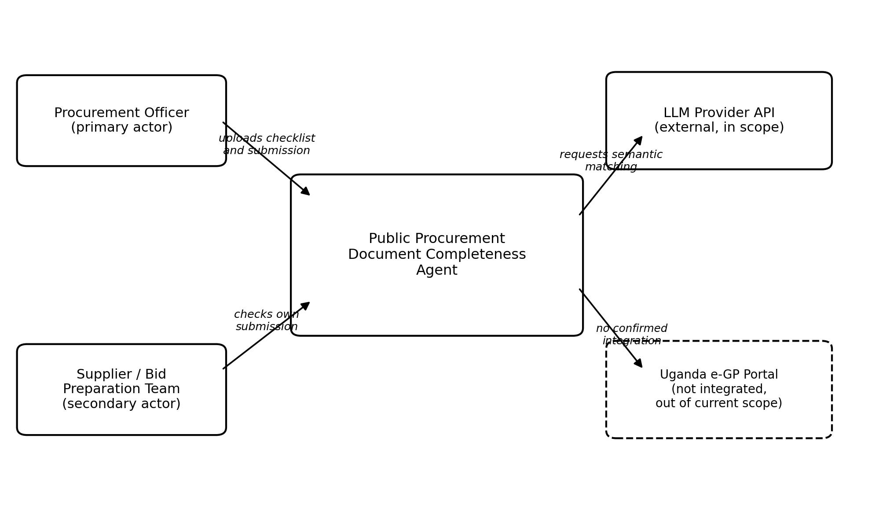
Figure 1. System context: actors, the proposed system, and its external dependencies
The LLM Provider API is shown as an external system because semantic matching, meaning the interpretation of a checklist requirement and the search for equivalent wording, is the core AI capability described in the charter, and the team's stated constraint is to use a language model agent by way of an API. The Uganda electronic government procurement portal is explicitly shown as not integrated. Neither the charter nor the user stories mention it, and the team has not confirmed it is in scope, so it is drawn but marked outside the current boundary rather than left out silently.

7.2 Component Architecture
Figure 2 breaks the system down into first pass components. The component boundaries follow the main flow already confirmed in Section 5, upload checklist, edit items, upload submission, match, classify, human review, export, with an additional dedicated component for the safety boundary refusals required by the acceptance criteria covering scoring, ranking, legal conclusions, and award recommendations.
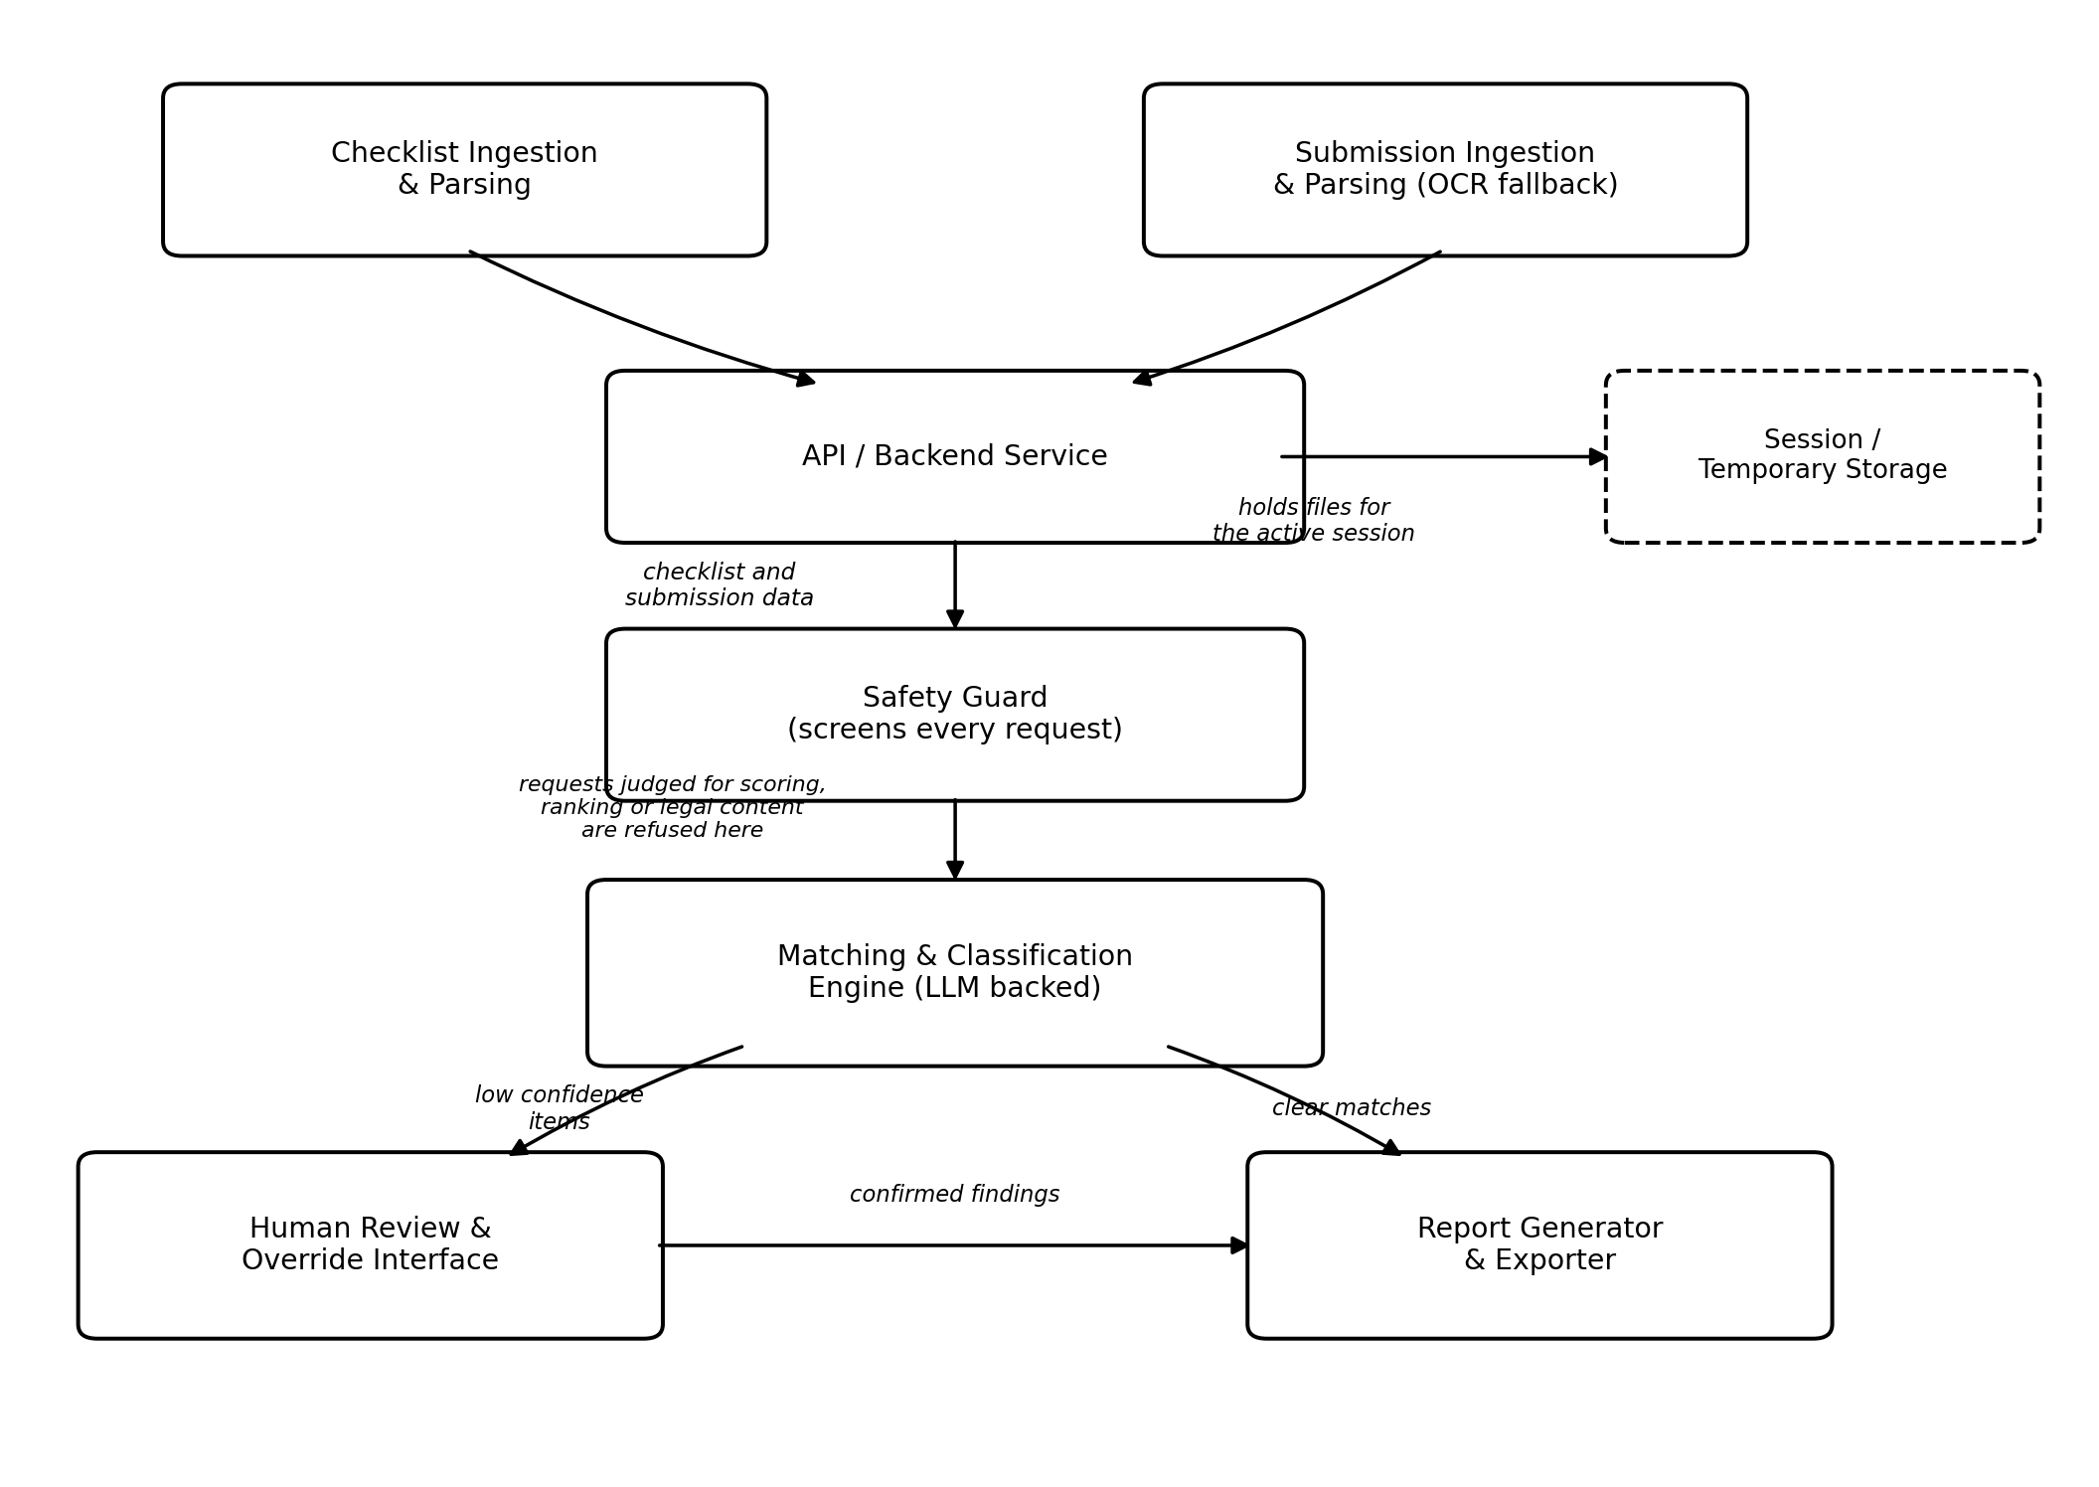
Figure 2. Proposed component architecture, prior to any technology selection
Table 2. Component descriptions
Component | Responsibility
API / Backend Service | Receives client requests, orchestrates the other components, and manages the session for a single completeness check in progress.
Safety Guard | Screens incoming requests before they reach the matching engine. Recognises requests for scoring, ranking, legal conclusions, or award recommendations, and returns a predefined refusal instead of processing them. Sitting at the API layer means no downstream component has to repeat this check on its own.
Checklist Ingestion and Parsing | Accepts PDF, CSV, or text checklist files, extracts a structured list of required items, and exposes them for the user to edit before a check is run.
Submission Ingestion and Parsing | Accepts the tender submission, extracts its text, and falls back to OCR for scanned or image based pages.
Matching and Classification Engine | The language model backed component that interprets each checklist requirement, searches the parsed submission for satisfying text, and classifies each item as found, not found, or requiring human review, recording a page, section, or snippet as evidence for found items.
Human Review and Override Interface | Presents items marked as requiring human review to the user and lets them confirm the tag as found or missing.
Report Generator and Exporter | Compiles the final classification list, evidence locations, and submission metadata into an exportable PDF or CSV, including the required completeness check only disclaimer.
Session and Temporary Storage | Holds uploaded files and intermediate parsing results for the duration of one check. Given the charter's constraint on data access, this is proposed as transient storage rather than a long term repository; the retention policy itself is still an open point.

7.3 Data Flow
- The user uploads a checklist. Checklist Ingestion and Parsing extracts the required items, and the user edits the list as needed.
- The user uploads a submission. Submission Ingestion and Parsing extracts its text, applying OCR if the file requires it.
- The API forwards both parsed sets to the Matching and Classification Engine, which calls the language model provider API to interpret and locate each requirement.
- The engine returns a classified list with evidence locations. Items with low confidence are routed to the Human Review and Override Interface.
- The user confirms or overrides the flagged review items, after which the Report Generator and Exporter compiles the final report for download.
At every stage in this sequence, the Safety Guard sits in front of the API layer. Any request asking the system to score, rank, compare submissions, draw a legal conclusion, or recommend an award is intercepted and refused before it can reach the matching engine.

7.4 Design Rationale
The component split follows directly from the confirmed main flow and acceptance criteria rather than from a generic template. A dedicated Safety Guard exists because four of the ten confirmed acceptance criteria are safety boundary refusals rather than completeness checking behaviour, and separating this concern means the refusal logic is enforced once, centrally, instead of being repeated across several components. The three way classification of found, not found, and requiring human review is carried into the Matching and Classification Engine as a first class output rather than a simple match or no match, because the acceptance criteria require a distinct review and override path for low confidence items. Session storage is deliberately scoped as transient, consistent with the charter's constraint that confidential live tender data should not be exposed during development and testing.

7.5 Candidate Technologies
The technologies below are proposed to fit the constraints already confirmed: a web and mobile focus, the language model by API constraint, PDF, CSV, and text input, and an OCR fallback. None of them have been confirmed by the team. They are offered here as a starting point for discussion rather than as settled decisions.
Table 3. Candidate technologies by architectural layer, not yet confirmed
Layer | Candidate technology | Why it fits
Client | A web front end, for example React | The reviewing officer works at a desk, which favours a web interface; the team's general mobile focus can be addressed separately once that scope question is settled.
Backend | A Python web framework, for example FastAPI or Django REST Framework | Straightforward to connect with both document parsing libraries and language model provider SDKs.
Checklist and submission parsing | A PDF text extraction library such as pdfplumber or PyMuPDF, plus a CSV or text parser, with an OCR engine such as Tesseract for scanned pages | Matches the confirmed input formats and the document quality constraint from the charter.
Matching and classification | A language model accessed by API, for example Claude or an OpenAI model, per the team's stated constraint | Called with the parsed checklist item and the relevant submission text to determine a match and a confidence level.
Report export | A PDF generation library and a CSV writer | Covers the two export formats the user stories require.

7.6 Assumptions and Constraints Carried Into This Architecture
- Data access: development and testing use public checklists and templates together with synthetic or anonymised submissions, not confidential live tenders.
- Document quality: scanned pages, images, and inconsistent formatting can reduce extraction accuracy, which is why an OCR fallback and a requiring human review path exist rather than a single deterministic parser.
- Language ambiguity: a submission may satisfy a requirement without matching its exact wording, which is why matching is proposed as language model based semantic interpretation rather than keyword search.
- Human oversight: a human reviewer remains in control of the final interpretation of every finding, reflected in keeping the Human Review and Override Interface a mandatory step before export rather than an optional one.

8. AI Boundary and Safety Matrix
It is not enough for the Agent to be useful. It has to be obviously and verifiably bounded, since the whole justification for automating this step rests on the boundary holding. The matrix below sets out, task by task, what falls to autonomous AI processing, what is handled by fixed deterministic rules, what needs explicit human approval, and what is forbidden outright regardless of how confident the system appears.
Table 4. AI boundary and safety matrix
Task | Category | How it works | Safety rule
Reading the requirements checklist | Autonomous AI | Extracts required clauses, attachments, and key criteria from procurement policy documents into a standard format. | Produces an editable list. A mandatory standard clause cannot be removed without an entry in the audit log.
File processing and validation | Deterministic code | Checks file types, verifies digital signatures and checksums, and extracts readable text. | Immediately rejects corrupted files, unreadable scans, or unsupported file extensions.
Clause detection | Autonomous AI | Uses natural language matching to find required clauses even when phrased differently, for example matching limitation of liability to standard indemnity terms. | Every match must link directly to the exact page number and passage text so the user can verify it.
Unclear or low confidence matches | Human approval required | When match confidence drops below eighty five percent, the system flags the clause for manual review. | The system must never guess or auto confirm unclear text. A human officer reviews and decides.
Calculating missing items | Deterministic code | Compares verified findings against the original checklist to produce a list of missing items. | Strict rule based comparison, with no AI guessing or altered results.
Report generation | Deterministic code | Pulls verified findings into standard report formats using pre-approved templates. | Automatically attaches the required legal notice and non evaluation disclaimer to every report.
Report approval and sign off | Human approval required | A procurement officer reviews all referenced text, checks the missing items, and grants final approval. | Reports cannot be published or sent to an evaluation team without explicit sign off from an authorised officer.
Quality or performance scoring | Strictly prohibited | Assigning scores, points, grades, or qualitative ratings such as strong, weak, or satisfactory. | The system blocks scoring requests outright. No evaluation metric is included in any system model or report.
Comparing or ranking proposals | Strictly prohibited | Comparing bidders against one another, or ranking proposals by completeness. | Every submission is reviewed in complete isolation. Cross submission comparison is disabled.
Legal validity checks | Strictly prohibited | Deciding whether a clause is legally binding, enforceable, or compliant with contract law. | The system only checks whether a required topic is present. A request for legal review triggers an immediate stop.
Award or disqualification recommendations | Strictly prohibited | Recommending whether to accept, approve, disqualify, or award a contract to a vendor. | System language rules block recommendation terms such as award or disqualify. Only the status labels present or missing are permitted.

Four operational rules run underneath this table. On the AI side, the system maps proposal text to checklist criteria using search and language models, pulls exact passages with page numbers as evidence, and marks each item with a plain confidence status. On the deterministic side, output formatting always follows a fixed template, missing items are calculated by simple subtraction against the full requirement list, prompts asking for scores, rankings, legal opinions, or award recommendations are blocked automatically, and an unalterable audit log records timestamps, user identities, document identifiers, and the settings used for each run.
Human approval is required at three points regardless of what the Agent finds: the officer must review and confirm the checklist before scanning begins, must personally decide any item flagged as unclear, and must initiate any follow up action such as a clarification request. A completeness report cannot be added to an official procurement record without an authorised officer's explicit sign off. Four actions are forbidden outright and cannot be triggered by any override: assigning a score or grade to a proposal, ranking or comparing proposals against each other, offering a legal opinion on enforceability or compliance, and recommending whether a vendor should be accepted, shortlisted, rejected, or awarded a contract.

9. Traceability
The chain below connects the problem described in Section 2 to the confirmed requirements and proposed functionality described in later sections. It is completed only where evidence actually exists; any link that has not yet been confirmed is marked as such elsewhere in this report rather than invented here for the sake of completeness.
Table 5. Traceability from problem to proposed functionality
Problem | Objective | Requirement / task | Proposed functionality and acceptance criteria
Manual completeness checks miss required items, are recorded inconsistently, and are discovered late. | Give a reviewer a faster and more consistent first pass completeness check while preserving full human decision authority. | Parse checklist, parse submission, locate evidence, classify as found, not found or requiring human review, then export report. | An agentic document completeness checker producing a classified, evidence linked completeness report, covering checklist ingestion, submission ingestion, matching, missing item flagging, report export, and the four safety boundary criteria.

Formal linkage to the course's approved objectives and the specific grading rubric for this deliverable cannot yet be completed, since those course level documents have not been supplied to the team. This is tracked as an open item in Section 10.

10. Information Gap Register
Rather than smoothing over what the team does not yet know, the register below keeps every open question visible, along with the ones that have since been resolved. Resolved items are kept rather than deleted, so the record of what changed and why stays intact.
Table 6. Information gap register
ID | Information required | Why it matters | Priority | Status
1 | Sector or type of procurement targeted, meaning goods, works, non consultancy services, or consultancy. | Checklist content and required documents differ by procurement category. | High | Open
2 | The specific checklist instance to be used for prototype development and testing. | Input formats are now confirmed as PDF, CSV, or text; the exact reference checklist is not. | Medium | Partially resolved, formats confirmed
3 | Identity of the primary and secondary user. | Changes the actor model and the system boundary. | High | Resolved, confirmed by the project charter
4 | Provenance of the synthetic submissions used for testing. | Needed to confirm the data is genuinely feasible and ethically clear to use. | Low | Mostly resolved, exact creation method still open
5 | Whether integration with Uganda's electronic government procurement portal is in scope. | Affects the system boundary and the architecture described in Section 7. | Medium | Open
6 | Whether a completeness count or percentage is an acceptable output. | The stated safety boundary excludes bid scoring. | High | Resolved, no scores, percentages, or grades of any kind
7 | Grading rubric specifics for this deliverable. | Needed to align the depth and structure of this report with the assessment criteria. | Medium | Open
8 | Target platform for this specific use case, meaning web, mobile, or both. | The team has a general web and mobile focus, not yet confirmed for this use case. | Medium | Open

11. Team and Roles
The project is carried out by Group H, Evening stream, consisting of Makmot Johnson Kabira, Mwesigwa Isaac, Bataringaya Bridget, and Jonathan Katongole. Roles are expected to rotate across the eight week project, but each member owns identifiable tasks within a given week and remains able to explain the system's major decisions and failures as a whole, not only the parts they personally built.
For Week 1, the group's effort split naturally along the four documents brought together in this report: framing the problem and writing the charter, defining the use case in detail against real regulatory sources, proposing the first architecture and context diagrams, and writing the AI boundary matrix that the rest of the design has to respect. Later weeks will assign more specific technical roles, such as application integration, AI engineering, quality and security, and documentation, once the architecture proposed in Section 7 moves from proposal to implementation.

12. Conclusion
The selected use case, a public procurement document completeness agent, is grounded in a real and verifiable stage of Uganda's procurement process, a real and evidenced problem at that stage, and the team's own project charter and user stories, which independently confirm the same problem, the same actors, and the same safety boundary. Its scope is kept deliberately narrow: the Agent locates, classifies, and reports; it does not judge, score, or rank.
The workflow set out in Section 6 and the architecture proposed in Section 7 give this use case a concrete shape, moving from an officer's upload through the Agent's bounded reasoning to a human sign off, with a dedicated Safety Guard component ensuring the boundary in Section 8 is enforced centrally rather than left to chance. Four information gaps remain open, covering the target sector, the canonical checklist instance, the scope of any e-GP integration, and alignment with the grading rubric, and are tracked in Section 10 rather than assumed away. As it stands, the use case defined here is a defensible starting point for the architecture and prompting work that follows in Week 2.

References
Global Advisory Experts. (2026, June 15). Uganda procurement law 2026: PPDA reforms, tribunal changes and what suppliers and contracting authorities must do. https://globaladvisoryexperts.com/public-procurement-uganda-2/
Ithy. (2025, May 21). Unlock your bidding potential: Essential documents for tendering with Uganda's Office of the Prime Minister. https://ithy.com/article/uganda-opm-bid-documents-t12vadls
Lawpoint Uganda. (2025, May 30). The Procurement Appeals Tribunal rules that clarification mechanisms under the PPDA (Evaluation) Regulations are strictly limited and cannot be used to cure material defects or omissions in a bid. https://www.lawpointuganda.com/post/the-procurement-appeals-tribunal-rules-that-clarification-mechanisms-under-the-ppda-evaluation-reg
Ministry of Education and Sports (Uganda). (2021). Standard bidding document for the procurement of works and goods (local government) [PPDA SBD]. https://www.education.go.ug/wp-content/uploads/2021/01/1-SBD-local-gvt.pdf
Public Procurement and Disposal of Public Assets Authority. (2003, as amended 2011 and 2021). Public Procurement and Disposal of Public Assets Act, 2003 (Cap. 205). https://pat.go.ug/sites/default/files/resources/PPDA%20ACT%20%202003.pdf
Public Procurement and Disposal of Public Assets Authority. (n.d.-a). Guidelines for bidding. https://ppda.co.ug/guidelines.php
Public Procurement and Disposal of Public Assets Authority. (n.d.-b). Frequently asked questions. https://www.ppda.go.ug/wp-content/uploads/2023/01/UPDATED-FAQS_compressed-2.pdf
Procurement Appeals Tribunal. (2026, March 6). D and D Law Publishing House Limited (in joint venture with Mail Solutions UK Limited trading as Kalamazoo) v Uganda National Examinations Board (Application No. 7 of 2026) [2026] UGPPDPAAT 10. Uganda Legal Information Institute. https://ulii.org/en/akn/ug/judgment/ugppdpaat/2026/10/eng@2026-03-06
Wikipedia. (n.d.). Public Procurement and Disposal of Public Assets Authority. https://en.wikipedia.org/wiki/Public_Procurement_and_Disposal_of_Public_Assets_Authority

